Introduction
In the current era of the information technology revolution, a profound understanding of computer systems and hardware serves as the essential foundation for almost every aspect of modern life, ranging from business and research to daily personal activities (Sairmaly, 2023). Informatics education at the junior high school level plays a critical role in honing digital literacy skills early on, effectively preparing students to navigate the challenges of an increasingly evolving digital world. Digital technology proficiency is no longer an elective skill but a fundamental necessity for both students and educators to ensure quality instruction and professional development in a tech-driven society (Yadav, 2024). Consequently, mastery of hardware concepts is a primary competency within the informatics curriculum that students must achieve to participate effectively in the digital age (Caspersen et al., 2024). However, teaching these technical concepts requires a structured and innovative approach to ensure that the foundational knowledge is transferred successfully to the younger generation.
Despite its importance, computer system material is frequently perceived by students as a difficult, abstract, and dry subject, leading to significant pedagogical challenges in the classroom. Conventional teaching strategies, which are often dominated by the lecture method, tend to create a passive learning environment that lacks engagement and fails to stimulate student interest (Osman et al., 2024). This lack of innovation in teaching methods often results in a significant decline in student learning motivation and participation. Research indicates that without effective and creative learning models, students struggle to grasp basic computer principles and their practical applications (Belsam, 2017). Therefore, there is an urgent need to transition from traditional teacher-centered approaches toward more interactive and innovative strategies that can simplify complex technical concepts.
Digital comics have emerged as a promising solution to these educational hurdles by combining visual narratives, characters, and humor to deliver instructional content (Huang et al., 2024). As a visual communication medium, comics are uniquely capable of transforming abstract technical information into a more concrete and accessible format through sequential panels and dialogue balloons. The integration of storytelling within digital comics helps capture students' attention and facilitates a more enjoyable reading experience compared to standard textbooks (Rutta et al., 2021). Previous studies have shown that comic-based media can effectively bridge the gap between serious learning and entertaining engagement, making it an ideal tool for secondary education (Granero‐Molina & Cadorna, 2025; Sarris, 2025). By leveraging visual appeal and a structured narrative, digital comics provide a relatable context for students, thereby reducing the cognitive load required to understand complex informatics topics.
The efficacy of digital comics in education is closely linked to their ability to stimulate both intrinsic and extrinsic motivation, which are primary drivers of academic success (Mamolo, 2022). When students are emotionally engaged through a compelling visual narrative, they tend to exhibit higher levels of curiosity, persistence, and enthusiasm during classroom activities (Julita & Isna, 2025). This increased motivation directly influences student engagement, encouraging them to be more focused and active in the learning process. Enhanced motivation serves as a psychological catalyst that allows students to absorb and retain technical information more effectively, ultimately leading to superior material mastery. Thus, the use of creative media like digital comics is not just about visual aesthetics but about creating a dynamic learning environment that supports the cognitive and affective needs of the students.
While several studies have explored the general use of comics in education, there is limited research that comprehensively analyzes the structural relationships between instructional strategies, media influence, motivation, and mastery in the specific context of informatics. This study aims to fill this gap by evaluating a conceptual model that links these variables using Structural Equation Modeling (PLS-SEM). The use of PLS-SEM provides a robust statistical framework to test the significance of these pathways and predict how digital comic interventions affect learning outcomes in a junior high school setting (Rahayu et al., 2023).

Literature Review and Hypothesis Development

Digital Comics as an Instructional Media in Informatics
Instructional media serves as a fundamental vehicle for delivering educational messages and stimulating students' cognitive and emotional responses during the learning process. This encompasses a broad spectrum of tools, ranging from traditional mediums like blackboards and textbooks to contemporary digital platforms such as interactive videos and online simulations (Kogila et al., 2020). These media are instrumental in facilitating effective communication between educators and learners, thereby enhancing the overall efficacy of instructional delivery (Alfurqan et al., 2019). The strategic selection and integration of these diverse instructional media are paramount for educators to achieve predetermined learning objectives and to foster a dynamic learning environment.
Digital comics, characterized by sequential panels, illustrations, and dialogue balloons, offer a unique pedagogical advantage by merging entertainment with education (Amrullah et al., 2024). In the context of informatics, where concepts like hardware architecture and computer systems are often perceived as overly abstract, comics provide a concrete visual framework that simplifies technical jargon. By utilizing humor and relatable narratives, digital comics can reduce cognitive load, allowing students to grasp the integrated functions of components such as the CPU and RAM more effectively (Apostolou & Linardatos, 2023). Furthermore, the web-based nature of modern digital comics ensures flexible access across various devices, fostering a more dynamic learning environment (Lesmono et al., 2018). This multimodal textual-visual format leverages narratives, characters, and designs specifically crafted to convey and elucidate educational information, making complex topics more accessible and engaging for students

Conceptualizing Student Motivation and Material Mastery
Learning motivation is a multifaceted psychological construct that dictates the intensity and persistence of a student's engagement in educational activities. Effective learning media, such as digital comics, play a crucial role in cultivating and sustaining this motivation by presenting information in an engaging and accessible format (Reinita et al., 2023). Such media serve as delivery systems for educational communications, facilitating the acquisition of knowledge and fostering active participation (Rina et al., 2020). Ultimately, the effective deployment of appropriate learning media is paramount for optimizing learning outcomes and enriching the educational experience (Nafala, 2022).
Within the informatics curriculum, high motivation is essential for students to navigate complex technical materials and achieve superior material mastery (Dewi et al., 2025). Material mastery refers to the level of an individual's comprehension and ability to apply concepts, theories, and technical information related to computer devices. Theoretical frameworks suggest that when learning materials are presented in an engaging visual format, they can trigger both intrinsic curiosity and extrinsic drive (O’Brien & Toms, 2008). This motivational surge acts as a catalyst, encouraging students to focus more intently and participate actively, which ultimately correlates with higher academic performance and a deeper understanding of digital technologies (Osmani & Tartari, 2024). Given that traditional print media comics often fail to develop intellectual understanding, e-comics address this by providing material, graphics, stories, and sample questions in an engaging format that mitigates boredom and enhances comprehension (Khoiri et al., 2024).

Conceptual Model and Hypothesis Development
This research proposes a structural model to evaluate the determinants of student performance in informatics education using PLS-SEM. The conceptual framework explores how instructional strategies and visual media collectively influence cognitive outcomes through the mediation of student motivation. Figure 1 shows the proposed conceptual model of this study.
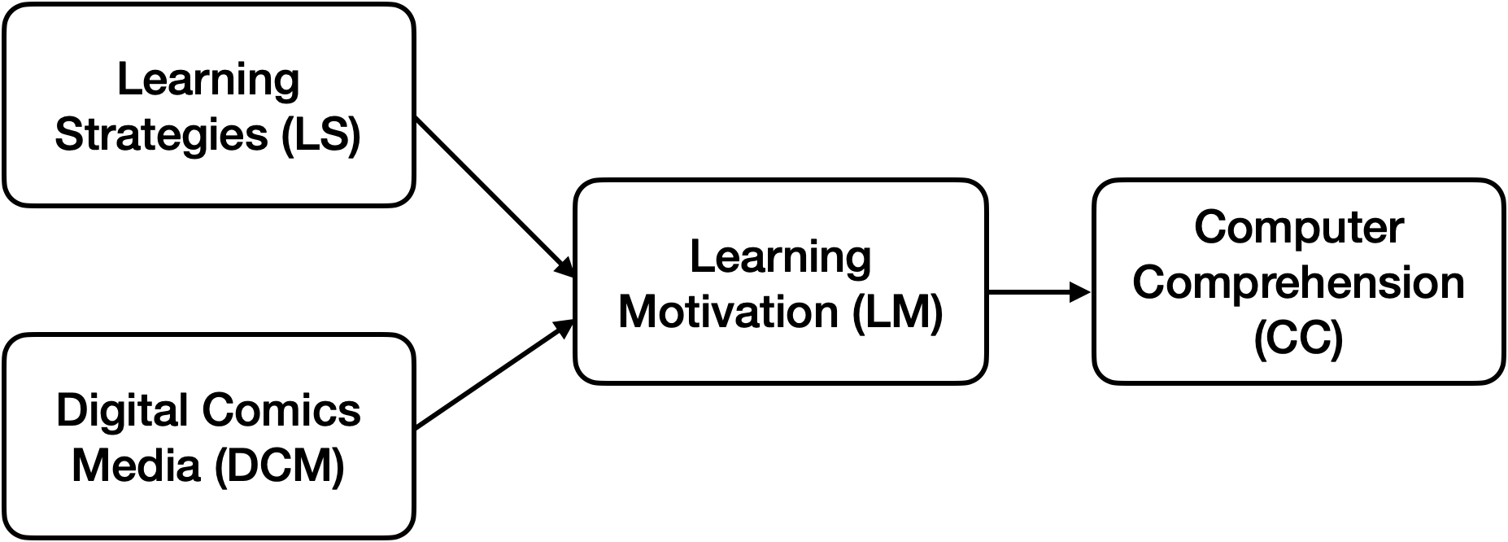
Figure 1. The proposed conceptual model
Based on this model, the following hypotheses are formulated:
H1: LS using comics significantly and positively influence student learning motivation (LM).
H2: DCM have a significant positive impact on LM.
H3: LM is a strong positive predictor of material mastery in informatics of CC.
H4: LM serves as a significant mediator between DMM interventions and students' technical CC.

Methodology

Research Design and Participants
This study employed a quasi-experimental research design (Cook, 2015), specifically utilizing the one-group pre-test post-test method (Roberts, 2020). This design is particularly suitable for educational interventions where a control group is not feasible, allowing for an accurate comparison of student outcomes before and after the introduction of digital comic media. By conducting pre-tests and post-tests on the same group of participants, the researcher can measure the direct effect of the treatment on the dependent variables more precisely. The experimental process followed a structured three-step model: assessing initial comprehension through a pre-test, providing the digital comic treatment, and evaluating the final comprehension via a post-test. This systematic approach ensures that any significant changes in student performance can be statistically attributed to the learning intervention. Several studies employing similar quasi-experimental designs, such as the nonequivalent control group design or posttest-pretest control group design, have demonstrated the efficacy of digital comic interventions in educational settings by comparing experimental and control groups (Laksana et al., 2024; Rizkiyah et al., 2025).
The participants for this experiment consisted of 26 students currently enrolled in the 7th grade at a junior high school in Central Java as provided in Table 1. The selection of this specific grade was based on the students' developmental stage and its alignment with the fundamental technical concepts presented in the informatics curriculum. The gender distribution within the group was perfectly balanced, comprising 50% male and 50% female students to ensure a representative sample of the student body. All participants shared a similar learning environment and academic background, which helps minimize external variance in the experimental results. This demographic consistency is vital for obtaining valid data regarding the effectiveness of visual narratives in a classroom setting.
Table 1. Participant information
Category |  | Frequency | Percentage (%)
Gender | Male | 18 | 50%
 | Female | 18 | 50%
Grade Level | 7th Grade | 36 | 100%
Total |  | 36 | 100%

Data Collection and Instrumentation
Data collection was conducted using digital questionnaires and performance tests administered through Google Forms to ensure efficiency and accuracy. The instruments were designed to measure four latent variables: Learning Strategies (LS), Digital Comics Media (DCM), Learning Motivation (LM), and Computer Comprehension (CC). The detail questions of the questionnaire is provided in Table 2. A four-point Likert scale (Strongly Disagree to Strongly Agree) was utilized for the questionnaire items to gauge student perceptions and psychological drive.
Table 2. Instrument measurement items
Variable | Code | Statement
Learning Strategies (LS) | LS1 | Comics used in learning make the lessons more interesting.
Learning Strategies (LS) | LS2 | Learning with comics helps me focus more on the material.
 | LS3 | The use of comics helps me understand the material better.
 | LS4 | Teaching with comics makes it easier for me to follow the flow of the lesson.
Digital Comics Media (DCM) | DCM1 | Comic content matches the computer device material studied.
Digital Comics Media (DCM) | DCM2 | Visualizations in comics help me understand difficult concepts.
Digital Comics Media (DCM) | DCM3 | The comic has an attractive visual quality.
 | DCM4 | The narrative in the comic makes it easier for me to understand the context of the material.
Learning Motivation (LM) | LM1 | I am more excited to attend class when comics are used as a learning medium.15
Learning Motivation (LM) | LM2 | Comics increase my curiosity about computer device material.
Learning Motivation (LM) | LM3 | I feel challenged to complete the material after reading the comic.
Learning Motivation (LM) | LM4 | I have a greater drive to study computer devices when the material is presented in comic form.
Computer Comprehension (CC) | CC1 | I understand computer device concepts better after using the comic.
Computer Comprehension (CC) | CC2 | I can explain computer device concepts more clearly after learning through the comic.
Computer Comprehension (CC) | CC3 | I feel more able to apply computer device concepts in real situations after learning through the comic.
Computer Comprehension (CC) | CC4 | I can complete tasks related to computer devices better after reading the comic.

Development of Digital Comic Media
The instructional media was developed using the Canva platform, focusing on the simplification of abstract hardware concepts through visual storytelling. The comic features a central character who guides the reader through technical explanations of hardware components such as the CPU, RAM, and storage devices. Figure 2 shows the developed digital comic media example employed in this study.
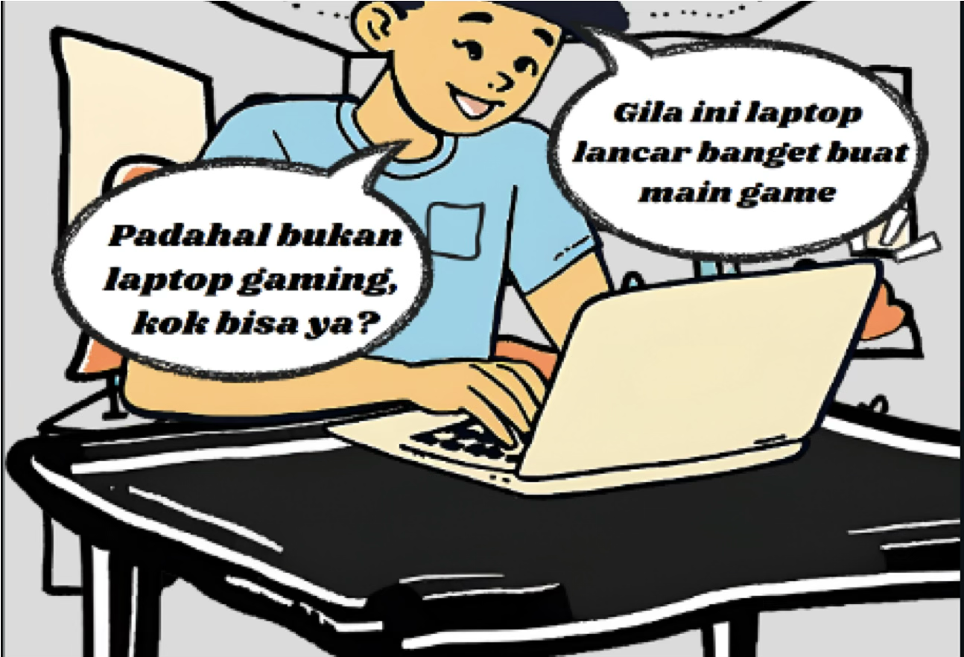
Figure 2. Digital comic interface preview

Data Analysis Procedures
The data analysis phase involved two distinct statistical approaches to provide a comprehensive evaluation of the research hypotheses. First, a descriptive statistical analysis and a Paired Sample T-Test were conducted to compare the pre-test and post-test scores, determining the significance of the improvement in student comprehension (Natsir et al., 2023). This comparative step is essential for verifying that the increase in student grades was not due to chance but was a direct result of the comic intervention. The T-test results provided the initial empirical evidence of the media's effectiveness in a real-world classroom environment (Suryatin & Sugiman, 2019).
Second, the study employed Partial Least Squares-Structural Equation Modeling (PLS-SEM) using SmartPLS software to analyze the complex relationships between the latent variables (Lu et al., 2021). This procedure began with the evaluation of the Outer Model to ensure that all indicators met the criteria for validity and reliability, such as Average Variance Extracted (AVE) and Composite Reliability (El‐Sherbeeny et al., 2024). Subsequently, the Inner Model was analyzed to test the structural pathways and determine the R-square values for learning motivation and material mastery. This advanced modeling approach allows for a deep understanding of how visual media indirectly influences comprehension through the mediation of student motivation.

Results and Discussion

Statistical Analysis of Pre-test and Post-test
The initial phase of this research involved a pre-test to establish a baseline for students' understanding of computer systems, focusing on hardware components. Descriptive analysis of the pre-test data revealed a mean score of 71.15, with individual scores ranging from a minimum of 20 to a maximum of 100. Regarding the distribution of learning outcomes, 34.61% of students fell into the "very low" category, while 38.46% achieved a "very high" rating. Crucially, the classical completeness rate at this stage was only 57.70%, with 11 out of 26 students failing to meet the minimum competency standard (KKM) of 75. These results, as detailed in Table 3, indicate that prior to the intervention, students' mastery was moderate and below the institutional passing threshold.
Table 3. Comparison of pre-test and post-test statistical results
Statistics | Pre-test | Post-test
Sample Size (N) | 26 | 26
Maximum Score | 100 | 100
Minimum Score | 20 | 50
Mean Score | 71.15 | 92.3
Classical Completeness (%) | 57.70% | 88.46%
Sig. (2-tailed) | - | 0.001

Following the implementation of the digital comic-based learning strategy, a post-test was conducted to measure its impact. The results demonstrated a significant improvement, with the mean score rising to 92.3. The shift in learning outcomes was substantial; the majority of students (80.76%) moved into the "very high" category, and the "very low" category decreased to 7.7%. Most importantly, the classical completeness rate surged to 88.46%, with 23 students successfully surpassing the KKM. This confirms the effectiveness of comic media in enhancing student mastery of informatics concepts.
To statistically validate these findings, a Paired Sample T-Test was performed. The analysis yielded a significance value (2-tailed) of p = 0.001, which is lower than the alpha level of 0.05 (p < 0.05). Consequently, the null hypothesis (H0) was rejected, and the alternative hypothesis (H1) was accepted. This statistical evidence confirms that the digital comic intervention had a significant influence on students' academic performance.

Structural Equation Modeling (SEM) Analysis
Following the standard guidelines by Hair et al. (2019), the evaluation of the PLS-SEM results was carried out in two main stages: the assessment of the measurement model (outer model) to ensure instrument reliability and validity, and the evaluation of the structural model (inner model) to test the proposed hypotheses.

Measurement Model Assessment (Outer Model)
The measurement model evaluation aims to confirm that the survey items accurately reflect their respective constructs. This was assessed through indicator reliability, internal consistency reliability, convergent validity, and discriminant validity. During the initial data trimming process, several indicators were removed to meet the strict statistical thresholds, resulting in a robust final model comprising three to four items per construct.
Table 4. Construct reliability and convergent validity
Construct | Indicators | Outer Loadings | Cronbach's Alpha | CR | AVE
Computer Comprehension (CC) | CC1 | 0.872 | 0.863 | 0.891 | 0.708
Computer Comprehension (CC) | CC2 | 0.856
 | CC3 | 0.73
 | CC4 | 0.897
Digital Comics Media (DCM) | DCM2 | 0.905 | 0.915 | 0.92 | 0.855
 | DCM3 | 0.912
 | DCM4 | 0.957
Learning Motivation (LM) | LM1 | 0.855 | 0.897 | 0.898 | 0.831
 | LM3 | 0.931
 | LM4 | 0.945
Learning Strategies (LS) | LS1 | 0.794 | 0.882 | 0.916 | 0.733
 | LS2 | 0.909
 | LS3 | 0.868
 | LS4 | 0.849

As presented in Table 4, the indicator reliability was established, with all remaining outer loadings exceeding the recommended threshold of 0.708. Furthermore, the internal consistency of the constructs was confirmed, as both Cronbach's Alpha and Composite Reliability (CR) values for all variables surpassed the 0.70 minimum requirement. To assess convergent validity, the Average Variance Extracted (AVE) was examined. The AVE values for all constructs were well above 0.50, demonstrating that the constructs explain more than half of the variance of their respective indicators.
Discriminant validity was strictly evaluated using the Heterotrait-Monotrait Ratio (HTMT) criterion, which is considered superior to traditional metrics. As shown in Table 5, the majority of the HTMT values fall below the conservative threshold of 0.85.
It is important to note a specific value in Table 5 regarding the relationship between Digital Comics Media (DCM) and Computer Comprehension (CC), which yielded an HTMT value of 0.904. While this slightly exceeds the strict 0.85 threshold, Henseler et al. (2015) suggest that an HTMT value up to 0.90 is statistically acceptable for constructs that are conceptually highly interrelated. In the context of interactive educational media, the respondents' perception of the visual media quality (DCM) and their perceived mastery of the material delivered through that specific media (CC) inherently share conceptual overlaps. Therefore, discriminant validity is considered established for the overall model.
Table 5. Discriminant Validity (HTMT Ratio)
 | CC | DCM | LM | LS
Computer Comprehension (CC)
Digital Comics Media (DCM) | 0.904
Learning Motivation (LM) | 0.875 | 0.721
Learning Strategies (LS) | 0.63 | 0.319 | 0.79

Structural Model Assessment (Inner Model)
Following the validation of the measurement model, the structural model was evaluated to determine its explanatory power and to test the hypotheses. Prior to the path analysis, collinearity issues were examined. The variance inflation factor (VIF) values for the inner model were all below the threshold of 3.0, indicating that collinearity is not a critical issue in this study.

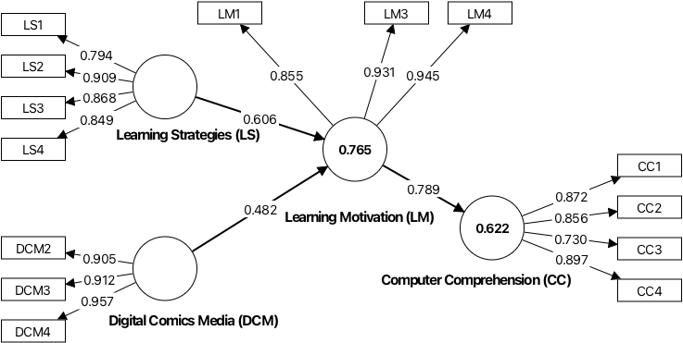
Figure 3. The final PLS-SEM structural model
Figure 3 illustrates the structural model and its predictive accuracy, measured by the coefficient of determination (R²). The model exhibits a substantial explanatory power for Learning Motivation (R² = 0.765), meaning that 76.5% of the variance in students' motivation is collectively explained by the learning strategies and the digital comics media. Furthermore, the model demonstrates a moderate to strong predictive capability for Computer Comprehension R² = 0.622), indicating that 62.2% of the variance in material mastery is driven by the students' motivation.To test the proposed hypotheses, a bootstrapping procedure with 5,000 subsamples was executed. The significance of both direct and specific indirect effects is summarized in Table 6.
Table 6. Summary of hypothesis testing
Hypothesis | Relationship (Path) | Path Coefficient (β) | T-Statistics | P-Values | Decision
H1 (Direct) | LS -> LM | 0.606 | 6.961 | 0 | Supported
H2 (Direct) | DCM -> LM | 0.482 | 5.464 | 0 | Supported
H3 (Direct) | LM -> CC | 0.789 | 9.978 | 0 | Supported
H4 (Indirect) | DCM -> LM -> CC | 0.38 | 4.567 | 0 | Supported

As detailed in Table 6, all direct effect hypotheses were strongly supported. Hypothesis 1 is accepted (β= 0.606, T = 6.961, p < 0.001), revealing that comic-based learning strategies (LS) significantly and positively influence student learning motivation. Similarly, Hypothesis 2 is supported (β = 0.482, T = 5.464, p < 0.001), confirming that the narrative and visual quality of digital comics media (DCM) also plays a critical role in driving motivation. Notably, the path coefficients show that pedagogical strategies have a slightly stronger impact on motivation compared to the media itself. Hypothesis 3 is also confirmed with the strongest direct effect in the model (β = 0.789, T = 9.978, p < 0.001), proving that elevated learning motivation is a highly significant predictor of informatics material mastery.Finally, the mediation analysis supports Hypothesis 4 (β = 0.380, T = 4.567, p < 0.001). The specific indirect effect demonstrates that learning motivation (LM) effectively serves as a significant mediator. This indicates that the deployment of digital comics (DCM) enhances students' technical comprehension (CC) primarily by first stimulating their learning motivation.

Discussion
The integration of digital comics into informatics education in this study yielded a transformative impact on both academic performance and student engagement. While the statistical analysis of pre-test and post-test scores explicitly confirms the cognitive gains and mastery of the material, the SEM provides a deeper, systemic understanding of the implicit psychological mechanics driving this improvement. Together, these analyses confirm that digital comics do not merely act as passive supplementary reading materials; rather, they function as dynamic instructional catalysts that fundamentally alter how students process, engage with, and ultimately master complex technical information.
The descriptive and inferential statistics from the cognitive assessments underscore a significant academic leap. Prior to the intervention, students evidently struggled with the abstract and intricate nature of computer systems and hardware components, as reflected by a pre-test mean score of 71.15 and a classical completeness rate of only 57.70%. However, following the digital comic intervention, the post-test results revealed a dramatic surge, with the mean score rising to 92.3 and classical completeness reaching 88.46%. The Paired Sample T-Test strongly validated this shift (p = 0.001). From a pedagogical perspective, this substantial cognitive improvement occurs because the visual narratives inherent in digital comics effectively reduce the students' cognitive load. By translating rigid, highly technical informatics concepts into sequential, visually digestible storylines, the comics bridge the gap between abstract computing theories and concrete understanding, enabling students who previously failed the minimum competency standard (KKM) to achieve mastery.
While the cognitive gains are empirically evident, the SEM analysis unveils the behavioral drivers behind this success, specifically highlighting the interplay between the media itself and the pedagogical strategy. Hypotheses 1 and 2 confirmed that both comic-based learning strategies (LS, β = 0.606) and the intrinsic quality of digital comics media (DCM, β = 0.482) significantly enhance student learning motivation (LM). A critical and profound insight here is the dominance of the learning strategy over the media quality. This finding implies that high-quality visual aesthetics and engaging narratives (DCM) are excellent tools for capturing initial attention, but they are insufficient on their own to sustain long-term engagement. It is the structured pedagogical integration, how the comics are actively utilized, discussed, and aligned with targeted learning objectives in the classroom (LS), that truly deepens the students' intrinsic motivation.
Furthermore, the most crucial finding of the structural model is the role of motivation as the definitive bridge to technical mastery. Hypothesis 3 revealed the strongest path coefficient in the entire model (β = 0.789), proving that learning motivation is a massive, direct predictor of computer comprehension (CC). This is further contextualized by the mediation analysis (H4), which confirmed that the digital comics intervention influences comprehension primarily through the stimulation of motivation (β = 0.380). In the context of informatics education, where topics often induce "technical anxiety" or apathy among students, digital comics effectively dismantle these affective barriers by fostering a low-anxiety, highly engaging learning environment. Consequently, the massive increase in the post-test scores was not a direct, automatic byproduct of merely reading a comic. Instead, it was the result of the digital comic successfully igniting a motivational drive that compelled students to actively engage with and understand the computer hardware material.
These synthesized findings offer critical practical implications for modern informatics and vocational education. Educators and instructional designers must recognize that the development of educational technology should not over-index on visual aesthetics at the expense of pedagogical design. To successfully replicate the high classical completeness rates observed in this study, the deployment of digital comics must be deliberately paired with interactive, student-centered learning strategies. By ensuring that visual media interventions are actively framed by strong pedagogical tactics, educators can predictably cultivate the high levels of learning motivation required to help students master complex, technical computing subjects.

Conclusion
This study concludes that digital comics exert a profound and transformative influence on student motivation and material mastery within informatics education. By utilizing SEM, the research establishes that while the visual narrative of digital comics effectively captures student interest, the structured pedagogical strategy embedded within the media is the dominant force driving intrinsic learning motivation. Furthermore, the findings solidify that this elevated motivation acts as a critical psychological mediator, successfully bridging the gap between engaging visual interventions and the actual cognitive mastery of complex computer concepts. Ultimately, strategically deployed digital comics evolve beyond mere supplementary reading, functioning as powerful instructional catalysts that systematically elevate academic performance.
Despite the significant findings, this study is constrained by a notable conceptual overlap between the respondents' perception of visual media quality and their perceived material mastery, reflecting a minor limitation in discriminant validity. Additionally, the experiment was limited to a specific demographic of seventh-grade students focusing solely on computer hardware components. Future research should explore these structural dynamics across broader educational levels and diverse informatics topics to validate generalizability. Investigating the long-term knowledge retention facilitated by digital comics would also provide deeper insights into their sustainable educational value.

References
Alfurqan, A., Tamrin, M. H., Trinova, Z., & Zuhdiyah, Z. (2019). The Problematics of Islamic Religious Education Teacher In Using of Instructional Media at SD Negeri 06 Pancung Soal Pesisir Selatan. AL-TA LIM, 26(1), 56–64. https://doi.org/10.15548/jt.v26i1.526
Amrullah, M. K., Riwanda, A., Marsiah, M., & Wilailak, W. (2024). Elevating Arabic Speaking Skills: Plotagon and Digital Comics as Catalysts for Enhanced Learning Engagement and Proficiency. Al-Ta Rib Jurnal Ilmiah Program Studi Pendidikan Bahasa Arab IAIN Palangka Raya, 12(1), 17–32. https://doi.org/10.23971/altarib.v12i1.7564
Apostolou, D., & Linardatos, G. (2023). Cognitive Load Approach to Digital Comics Creation: A Student-Centered Learning Case. Applied Sciences, 13(13), 7896–7896. https://doi.org/10.3390/app13137896
Belsam. (2017). Visualizing Computer Programming in a Computer-based Simulated Environment. International Journal of Advanced Computer Science and Applications, 8(8). https://doi.org/10.14569/ijacsa.2017.080848
Caspersen, M. E., Gal‐Ezer, J., McGettrick, A., & Nardelli, E. (2024). European Digital Transformation Needs Indicators of Informatics Competence. ACM Inroads, 15(4), 74–81. https://doi.org/10.1145/3696791
Cook, T. D. (2015). Quasi‐Experimental Design. Wiley Encyclopedia of Management, 1–2. https://doi.org/10.1002/9781118785317.weom110227
Dewi, S., Surur, M., & Jaya, F. (2025). Enhancing informatics learning through android-based interactive media: A development study with the ADDIE model. ASATIZA Jurnal Pendidikan, 6(3), 234–249. https://doi.org/10.46963/asatiza.v6i3.2822
El‐Sherbeeny, A. M., Alsetoohy, O., Sheikhelsouk, S., Liu, S., & Kamar, M. A. (2024). Enhancing hotel employees’ well-being and safe behaviors: The influences of physical workload, mental workload, and psychological resilience. Oeconomia Copernicana, 15(2), 765–807. https://doi.org/10.24136/oc.3018
Granero‐Molina, J., & Cadorna, E. A. (2025). Enhancing Filipino Students’ Learning Outcomes in Physics Using Comic-Based Learning Materials. International Journal of Learning Teaching and Educational Research, 24(11), 185–204. https://doi.org/10.26803/ijlter.24.11.9
Hair, J. F., Risher, J. J., Sarstedt, M., & Ringle, C. M. (2019). When to use and how to report the results of PLS-SEM. European Business Review, 31(1), 2–24.
Henseler, J., Ringle, C. M., & Sarstedt, M. (2015). A new criterion for assessing discriminant validity in variance-based structural equation modeling. Journal of the Academy of Marketing Science, 43(1), 115–135.
Huang, Y., Rahman, A., & Yahaya, M. F. bin. (2024). Applying Comics as Learning Tools: A Thematic Review. International Journal of Academic Research in Progressive Education and Development, 13(3). https://doi.org/10.6007/ijarped/v13-i3/22072
Julita, R., & Isna, N. (2025). The Use Of English Animated Videos To Improve Students’ Motivation. Educatio, 20(2), 387–398. https://doi.org/10.29408/edc.v20i2.31866
Khoiri, N., Lilyani, F. S. T., & Wijayanto, W. (2024). E-comic as a media to build an understanding of newtons concepts. Momentum Physics Education Journal, 8(1), 154–165. https://doi.org/10.21067/mpej.v8i1.8478
Kogila, M., Ibrahim, A. B., & Zulkifli, C. Z. (2020). A Powerful of Digital Storytelling to Support Education and Key Elements from Various Experts. International Journal of Academic Research in Progressive Education and Development, 9(2). https://doi.org/10.6007/ijarped/v9-i2/7483
Laksana, S. D., Ariyanto, A., Tajab, Moh., Syam, A. R., & Sumaryanti, L. (2024). Comic Strip Media Assisted by Digital Gamification: Increasing Student Behavior Targets and User Engagement in the Learning Process. E3S Web of Conferences, 500, 5006–5006. https://doi.org/10.1051/e3sconf/202450005006
Lesmono, A. D., Bachtiar, R. W., Maryani, M., & Muzdalifah, A. (2018). The Instructional-Based Andro-Web Comics on Work and Energy Topic for Senior High School Students. Jurnal Pendidikan IPA Indonesia, 7(2), 147–153. https://doi.org/10.15294/jpii.v7i2.14245
Lu, K., Yang, H. H., Shi, Y., & Wang, X. (2021). Examining the key influencing factors on college students’ higher-order thinking skills in the smart classroom environment. International Journal of Educational Technology in Higher Education, 18(1). https://doi.org/10.1186/s41239-020-00238-7
Mamolo, L. A. (2022). Students’ evaluation and learning experience on the utilization of Digital Interactive Math Comics (DIMaC) mobile app. Advances in Mobile Learning Educational Research, 2(2), 375–388. https://doi.org/10.25082/amler.2022.02.006
Nafala, N. M. (2022). IMPLEMENTASI MEDIA KOMIK DALAM PEMBELAJARAN UNTUK MENINGKATKAN MOTIVASI BELAJAR SISWA. Al-Fikru Jurnal Pendidikan Dan Sains, 3(1), 114–130. https://doi.org/10.55210/al-fikru.v3i1.571
Natsir, T., Rasyid, A., & Bassey, S. A. (2023). The SAVI Learning Model and the 21st Century Skills: Developing Critical Thinking, Collaboration, and Creativity in Students Vocational High School. International Journal of Environment Engineering and Education, 5(1), 27–34. https://doi.org/10.55151/ijeedu.v5i1.96
O’Brien, H. L., & Toms, E. G. (2008). What is user engagement? A conceptual framework for defining user engagement with technology. Journal of the American Society for Information Science and Technology, 59(6), 938–955. https://doi.org/10.1002/asi.20801
Osman, I., Taib, N. M., Yazid, Z. A., Daud, S., & Othman, M. Z. (2024). Exploring the Usability and Engagement of Students in an Educational Board Game on Personal Financial Planning. Information Management and Business Review, 16, 76–85. https://doi.org/10.22610/imbr.v16i1(i).3662
Osmani, S., & Tartari, D. (2024). The Impact of Digital Technology on Learning and Teaching: A Case Study of Schools in Durrës, Albania. Journal of Educational and Social Research, 14(6), 193–193. https://doi.org/10.36941/jesr-2024-0165
Rahayu, N. S., Dhiaullah, M. H., & Marsha, A. (2023). Utilizing e-learning and user loyalty with user satisfaction as mediating variable in public sector context. International Journal of Data and Network Science, 7(3), 1341–1348. https://doi.org/10.5267/j.ijdns.2023.4.004
Reinita, R., Jannah, M., & Sandika, F. A. (2023). The practices of digital comic media based on the PBL model in elementary school. Jurnal Inovasi Teknologi Pendidikan, 10(2), 149–157. https://doi.org/10.21831/jitp.v10i2.58625
Rina, N., Suminar, J. R., Damayani, N. A., & Hafiar, H. (2020). Character Education Based On Digital Comic Media. International Journal of Interactive Mobile Technologies (iJIM), 14(3), 107–107. https://doi.org/10.3991/ijim.v14i03.12111
Rizkiyah, R., Nurkholis, N., & Setiana, D. (2025). The Effect of Using Digital Comics on Science Learning Outcomes of Grade VI SDN 1 Japurabakti. JURNAL ILMIAH GLOBAL EDUCATION, 6(4), 2370–2384. https://doi.org/10.55681/jige.v6i4.4471
Roberts, C. (2020). The implications of noncompliance for randomized trials with partial nesting due to group treatment. Statistics in Medicine, 40(2), 349–368. (33118193). https://doi.org/10.1002/sim.8778
Rutta, C. B., Schiavo, G., Zancanaro, M., & Rubegni, E. (2021). Comic-based Digital Storytelling for Content and Language Integrated Learning. Educational Media International, 58(1), 21–36. https://doi.org/10.1080/09523987.2021.1908499
Sairmaly, F. A. (2023). Human Capital Development and Economic Growth: A Literature Review on Information Technology Investment, Education, Skills, and Productive Labour. Jurnal Minfo Polgan, 12(1), 679–693. https://doi.org/10.33395/jmp.v12i1.12491
Sarris, K. (2025). Beyond the Panels: Comics as Tools for Learning. https://doi.org/10.31219/osf.io/vycbu
Suryatin, S., & Sugiman, S. (2019). Comic book for improving the elementary school students’ mathematical problem solving skills and self-confidence. Jurnal Prima Edukasia, 7(1), 58–72. https://doi.org/10.21831/jpe.v7i1.10747
Yadav, S. (2024). Enhancing Digital Competencies of Teachers. In Advances in educational marketing, administration, and leadership book series (pp. 109–134). IGI Global. https://doi.org/10.4018/979-8-3373-1692-5.ch005

